Source ID – 923140094

Source Title - Chinese Journal of Ship Research

URL - <https://english.ship-research.com/en/article/current>

1.Go to the URL and capture the metadata as shown below.

**Note: Both English and Chinese TOC should be added in this.**

Article title

PDF

DOI

Volume

Year

Issue

Page Range

2.Month can be extracted from a downloaded PDF.

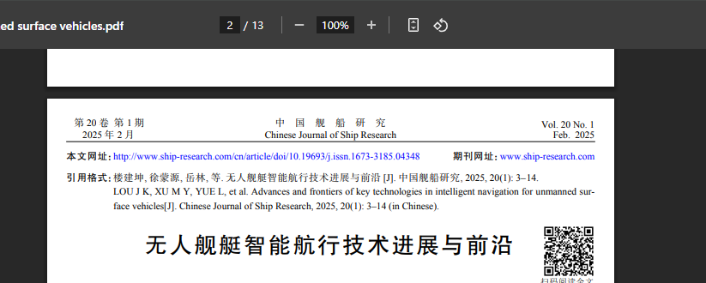

Month

Month is available on the 2nd page of the PDF.

“Feb” should be captured as “February”